20MCA136 – NETWORKING & SYSTEM ADMINISTRATION LAB Dept. of Computer Applications

|  |
| --- |
| **Name: VYSHNAV SURESH**  **Roll No: 56**  **Batch: B**  **Date: 12-05-2022** |

**NETWORKING & SYSTEM ADMINISTRATION LAB**

**Experiment No.: 21**

# Aim

Write a menu driven shell script to perform mathematical operations.

**Program**

echo "Enter two Numbers:"

read a

read b

echo "1. Addition"

echo "2. Subtraction" echo "3. MUltiplication" echo "4. Division"

echo "5. Exit"

echo "Enter your choice!" read ch

case $ch in

1)res=`echo $a + $b | bc`

;;

2)res=`echo $a - $b | bc`

;;

3)res=`echo $a \* $b | bc`

;;

4)res=`echo "scale=2; $a + $b" | bc`

;;

esac

echo "Result : $res"

Amal Jyothi College of Engineering, Kanjirappally 20MCA136 – NETWORKING & SYSTEM ADMINISTRATION LAB Dept. of Computer Applications

# Output screenshot

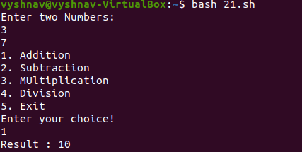

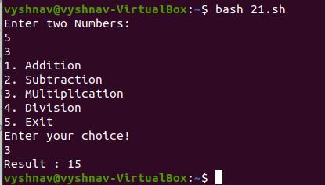

Amal Jyothi College of Engineering, Kanjirappally